Screen Based Trading System

GUI Test Plan

Draft

Prepared by:

Nick DePasquale

Date: March 17, 2003
Figure 1 - Login

Login

Number | Description | Expected Results | Expected Results Achieved?
20.1.0.1 | Login to Trader GUI using valid Trader ID XXX. | Login Successful

User ID
The User Id is used by the system to determine the role of the user logging in. Based on this role the Trader GUI enables and disables the appropriate functionality to meet the System’s authorizations.

User Roles

Marketmaker
In addition to the Broker’s functionality:

Quote (user based)
Entry
Cancel
Update
Query
Status

Receive RFQs

Broker Dealer
Same as Customer Broker-Dealer

Customer Broker-Dealer
Order (user based)
Entry
Cancel
Cancel Replace
Update
Query
History
Status

Send Quote Request
Book Depth
Market History
Activity Log
Trade Log
Market Data

Firm Broker
Order (All firm users based)
Entry
Cancel
Cancel Replace
Update
Query
History
Status

Send Quote Request
Book Depth
Market History
Activity Log
Trade Log
Market Data

Firm Display
Order (All firm users based)
Query
Status

Book Depth
Market History
Activity Log
Trade Log
Market Data

Class Display
Market Data

Order Entry

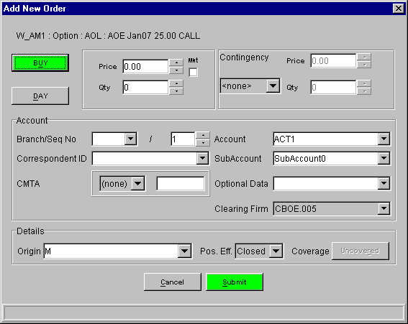
Figure 2 - Order Entry
Generic Order Entry Steps

Number | Description | Expected Result | Expected Result Achieved?
1 | Login with appropriate role  see Login and User Roles | User logged in
2 | Open a Market Display Window  see Market Display | Market Display window opened
3a | From the Market Display Window, select a product and right mouse click. | A menu will display.
3a1 | From the Order Menu, select Add New Order. | The Add Order window will display.  Order will be pre-filled to Buy at Market Ask Price and Quantity (if any). TIF will default to Day. Contingency will default to None.
3b | Or select a product and use Ctlr+Shift+N | The Add Order window will display.  Order will be pre-filled to Buy at Market Ask Price and Quantity (if any). TIF will default to Day. Contingency will default to None.
4 | Verify that the price and quantity fields are filled. If not, enter a valid price and desired quantity.  Change the order to Sell by clicking the BUY button to toggle (see Toggle Buttons Notes )  Select Open order by selecting Open from the Poss. Eff. combo box.  Enter a Branch if not using the Branch Default  Other account defaults may be set by the Miscellaneous Preferences  Verify data.
5 | To process the order, click Submit. | Button may change to “Confirm”. (See Order Confirmation for more details)  Or the Add Order window will close

Limit Orders
- Enter price by typing or using spinner on the Price field.

Market Orders
- Click the MKT checkbox next to the price filed

Contingency Orders
- Select type from the Contingency sub panel’s list of allowed Contingency types
- As applicable the Price and Qty fields in this sub panel will become enabled

Branch Notes
- A branch must be at least 1 character
- Only capital letters A-Z are allowed, no other numbers or symbols.
- Sequence number is auto generated by the GUI. To change it just enter as you would a qty
- If sequence number become out of synch on can use the option on the Miscellaneous Preferences Window to reset this value

Toggle Button Notes
The “Buy” button is a toggle button. When one presses it one will get the opposite – a “Sell” – press it again and it will be a “Buy” order. The color of the button is determined by the side.
“Buy” is green. “Sell” is yellow.

“Day” is also a toggle button. “GTC” is the other option

“Uncovered” is also a toggle button. “Covered” is the other option.

Order Confirmation
The Trader GUI has user preferences to set to determine when to require Order Confirmation.
On the dialog in Miscellaneous Preferences there is a check box to enable confirmation when qty exceeds limit and the limit value. The confirmation will be required when both of these conditions are met.

Branch Default
The Trader GUI has user preferences to set the default Branch.
On the dialog in Miscellaneous Preferences there is an Order Entry Defaults panel that contains a Branch filed. Follow the rules described in the Branch Notes for entering a valid Branch.

Strategy / Complex Orders
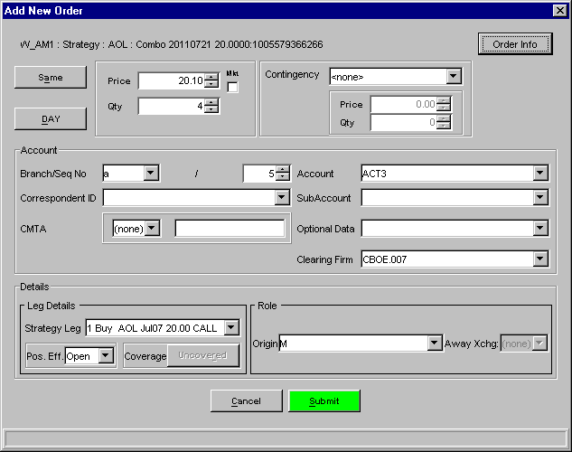

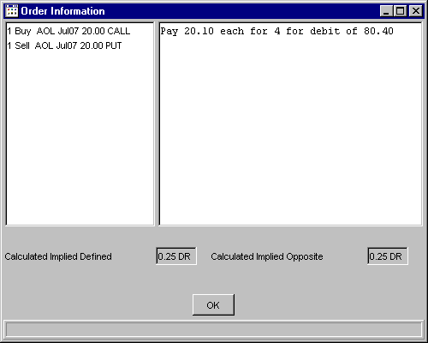

Miscellaneous Preferences

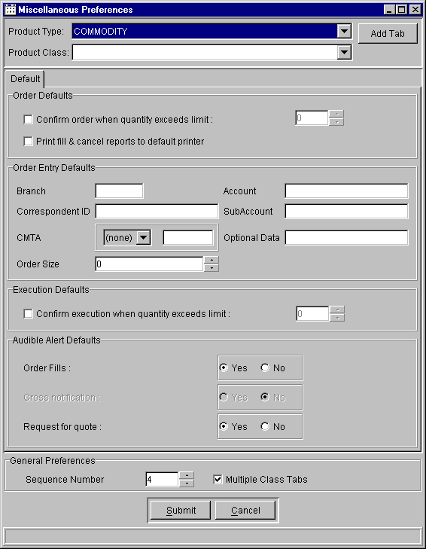
Figure 3 - Miscellaneous Preferences
Number | Description | Expected Results | Expected Results Achieved?
1 | Select Preferences – Miscellaneous Preferences from the Start menu | The Miscellaneous Preferences window appears
2 | Change the Branch and Correspondent ID (always 3 characters and 4 characters, respectively), and click”Submit” | The Miscellaneous Preferences window closes
3 | Enter an Order so that it won’t be canceled by the system (Order may trade, however).  See Order Entry for details | The Branch and Correspondent ID should display in the Order Entry dialog
4 | Go back to the Miscellaneous Preferences dialog. Check the “Confirm order when quantity exceeds limit:” checkbox, and enter a limit number. Click”Submit” | The Miscellaneous Preferences window closes
5 | Enter several Orders with quantities above, at, and below this limit number. | On trades above the limit number, the “Submit” button should turn into a red “Confirm” button and require you to click it again to submit the trade

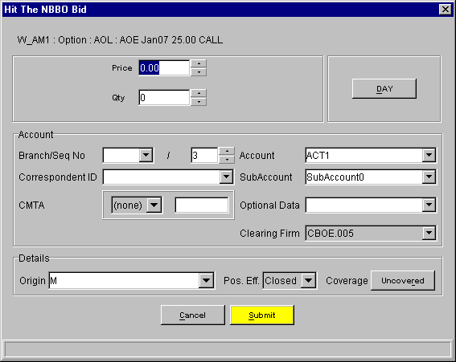
Figure 4 - Hit the Bid

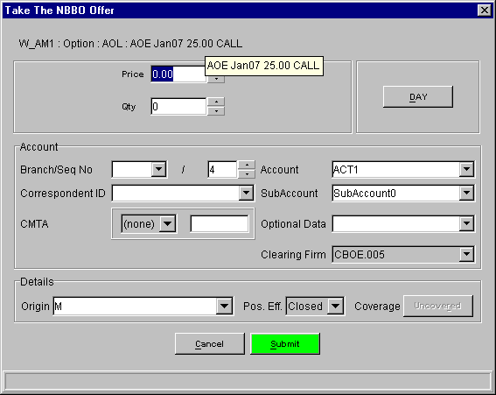
Figure 5 - Take the Offer

Hit Bid / Take Offer (CBOE and NBBO)

The only difference between this and the Order Entry is the combination of DAY and IOC. Lost are the GTC and all the other contingency types. Also these dialogs use the Execution Default value for the quantity confirmation.

DAY toggles to IOC in these cases not GTC as the Order Entry, for this reason it is moved to the other side of the panel to avoid confusion.

The only difference between the NBBO bid/offer and CBOE bid offer is the price and quantity fields being filed with the appropriate data.

The Execute menu contains 4 choices:
Hit the Bid (Cntl+Shift+B)
Take the Offer (Cntl+Shift+O)
Hit the NBBO Bid (Cntl+Shift+H)
Take the NBBO Offer (Cntl+Shift+T)

Quote Entry

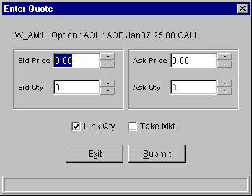
Figure 6 - Enter Quote

Number | Description | Expected Results | Expected Results Achieved?
 | From the Market Display Window, select a product.  See Market Display and Add Class | Selected series will appear highlighted.
 | From the menu bar, select Quote. | Quote menu is displayed.
 | From the quote menu, select Enter Quote. | The quote entry window will display below the ticker. Selected product and series will be pre-filled.
 | Or use Cntl+Shift+Q | The quote entry window will display below the ticker. Selected product and series will be pre-filled
 | Enter valid bid and ask prices. Enter valid bid quantity and ask quantity.  Click submit.  See Quote Defaults for user default options  See Link Quantity and Take Market for more convenience functions. | Quote entry window will close. Market Display Window will show price and quantity of quote just entered in “My Best” columns.

Quote Entry Notes
- Quote entry has 4 basic entry fields. Bid price and size and Ask price and size.
- Just as for Order Entry it has the same price and size validation.

Link Quantity
The “Link Qty” check box is a short cut to enter the same size for bid and ask.

Take Market
The “Take Mkt” check box is a short cut to getting the current market as one’s quote.

Quote Defaults
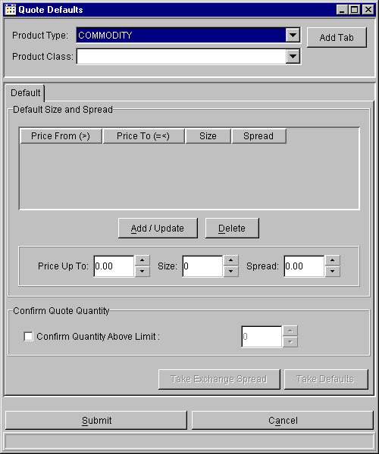
Figure 7 - Quote Defaults

Number | Description | Expected Results | Expected Results Achieved?
1 | Select Preferences – Quote Defaults from the Start menu. | The Quote Defaults window should display a variety of Quote settings for the currently logged-in user
2 | Check the “Confirm Quantity Above Limit:” checkbox and enter a quantity. Click “Submit” | The Quote Defaults window closes
 | Enter several quotes, with quantities above, at, and below this limit number.  See Quote Entry for details | On Quotes above the limit number, the “Submit” button should turn into a red “Confirm” button and require you to click it again to submit the Quote

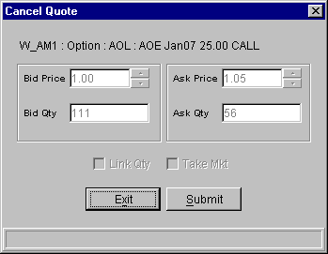
Figure 8 - Cancel Quote

Cancel Quote

The Cancel Quote dialog is straight forward. It shows the quote you have selected and your only options are to Cancel the Quote or Exit the dialog and do nothing.

Number | Description | Expected Results | Expected Results Achieved?
1 | Login with a role that allows Quote entry.  See Login and User Roles  Enter a quote  See Quote Entry | Quote entered and accepted by system, without trading or being canceled.
2 | On the Market Display Window, click on the product quoted. | Product Highlighted.
3 | From the quote menu on the menu bar, select cancel quote.  Or use Cntl+Shift+C to display the Cancel Quote | The Quote Cancel window will display on the Market Display window. It will be pre-filled with the Bid Price and Quantity and Ask Price and Quantity of the quote.
4 | Click Submit. | Quote Cancel window closes. Quote is canceled. No bid or offer will appear in the “My Best” columns for that product.

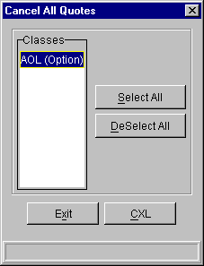
Figure 9 - Cancel All Quotes

Cancel All Quotes
The Cancel All Quotes dialog has the option to select by Class and Type, which quotes to cancel.
There are convenience buttons to select and deselect all Classes.

Number | Description | Expected Results | Expected Results Achieved?
 | Enter Quotes for at least 1 product in 4 or more Product Classes.  Verify the quotes are not traded or canceled | Quotes accepted by the system
 | From the quote menu, select Cancel All Quotes.  Or use Cntl+Shift+A | The Cancel All Quotes window will display.
 | Click Select All | All classes appear highlighted.
 | Click Cancel. | Confirmation button appears.
 | Click Confirm | Confirmation accepted
 | Select Order Status from the Orders menu. | Order Status window opens. No quotes will appear for the canceled classes.

Number | Description | Expected Results | Expected Results Achieved?
 | Enter Quotes for at least 1 product in 4 or more Product Classes.  Verify the quotes are not traded or canceled | Quotes accepted by the system
 | From the quote menu, select Cancel All Quotes.  Or use Cntl+Shift+A | The Cancel All Quotes window will display.
 | Hold down the [Ctrl] key and highlight 3 of the classes where quotes were entered. | Selected classes appear highlighted.
 | Click Cancel. | Confirmation button appears
 | Click Confirm | Confirmation accepted
 | Select Order Status from the Orders menu. | Order Status window opens. No quotes will appear for the canceled classes. Quotes will appear for classes not selected for Cancel

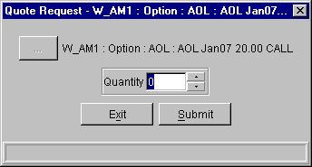
Figure 10 - Quote Request

Quote Request
This dialog allows the user to request a quote for a particular product, and optionally specifying a Quantity.

Number | Description | Expected Results | Expected Results Achieved?
 | From the Menu Bar, Select Quote | Quote menu appears.
 | From the market display window, select a current series. | Series highlighted
 | From the Quote menu, select Quote Request  Or use Ctrl+Shift+R | The Quote Request window appears for the selected series.
 | Enter a quantity. | Quantity displays in Quote Request window.
 | Click submit. | The system will send the RFQ to all Marketmakers assigned to that class. The RFQ button will flash.

Cancel Order

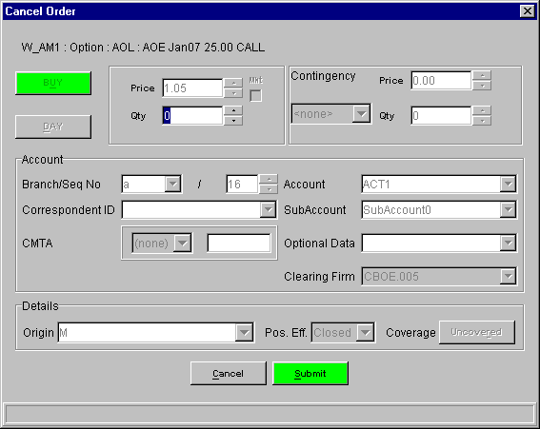

Number | Description | Expected Result | Expected Result Achieved?
 | Enter an Order so that it won’t trade or be canceled by the system.  See Order Entry for details | Order entered and available qty is the same as original qty
 | On the Order Status Window select your selection criteria in such a way as to view the order you entered.  See Order Status for details  Select the order entered during pre-test. | Order highlighted.
 | Right-click on the order. | Pulldown menu appears.
 | Select Cancel. | Cancel Order pop-up appears.
 | Click submit.  Options include changing the cancel quantity | The Cancel dialog is removed.  The Available Quantity should be decremented by the cancel quantity.  See Order Status for details

Cancel Replace Order
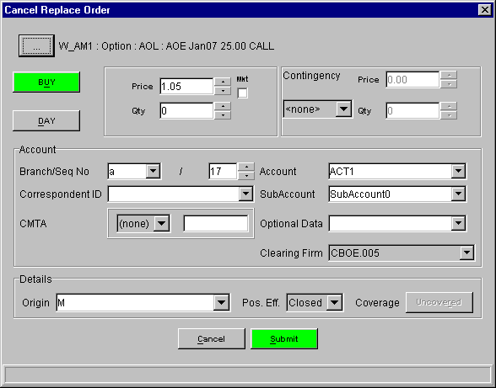

Number | Description | Expected Result | Expected Result Achieved?
 | Enter an Order so that it won’t trade or be canceled by the system.  See Order Entry for details | Order entered and available qty is the same as original qty
 | On the Order Status Window select your selection criteria in such a way as to view the order you entered.  See Order Status for details  Select the order entered during pre-test. | Order highlighted.
 | Right-click on the order. | Pulldown menu appears.
 | Select Cancel Replace. | Cancel Replace pop-up appears.
 | The existing order is displayed.  Change fields and click submit. | The Cancel Replace dialog is removed.  The Original Order should be completely canceled and a new order added  See Order Status for details

Update Order

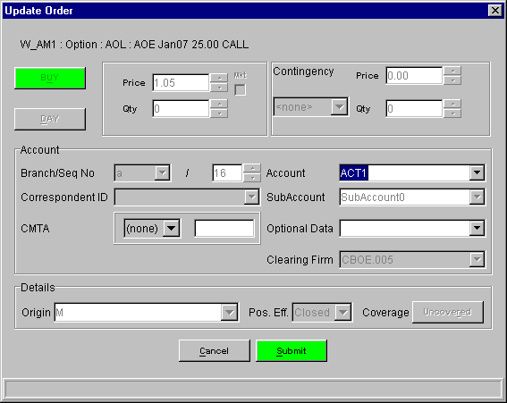

Number | Description | Expected Result | Expected Result Achieved?
1 | Enter an Order so that it won’t trade or be canceled by the system.  See Order Entry for details | Order entered and available qty is the same as original qty
2 | On the Order Status Window select your selection criteria in such a way as to view the order you entered.  See Order Status for details  Select the order entered during pre-test. | Order highlighted.
3 | Right-click on the order. | Pulldown menu appears.
4 | Select Update. | Cancel Order pop-up appears.
5 | Account  Optional Data  CMTA  The above fields are the only available fields that can be changed
6 | Click submit. | The Update dialog is removed.  Of the fields that were changed, only Account is displayed on the Order Status. Verify it is changed.  Trading priority should not be changed.  See Order Status for details
7 | Repeat steps 1-5 and verify that the  Optional Data and CMTA fields are updated.

Trades Log

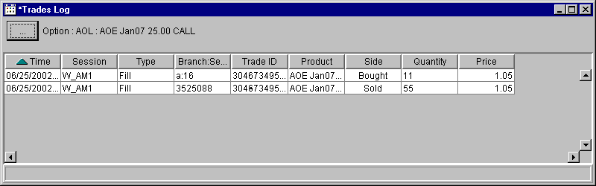

Number | Description | Expected Result | Expected Result Achieved?
1 | Enter several Orders so that they will trade.  See Order Entry for details | Orders appear as traded on Market Display window
2 | Select Trades Log – Create New Window from the Start menu | Trades Log window opens, with a row for Bought and a row for Sold for each trade you entered.

Activity Log
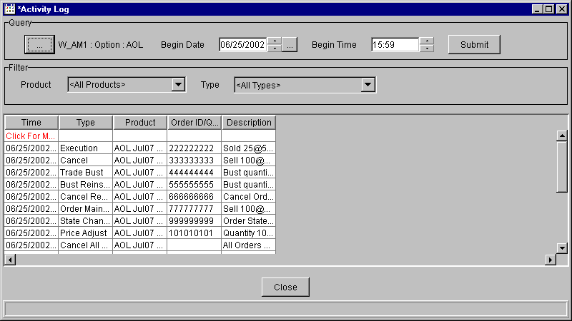

Number | Description | Expected Result | Expected Result Achieved?
1 | Enter several Quotes and Orders.  See Quote Entry and Order Entry for details | Quotes and Orders appear on Market Display window
2 | Select Activity Log – Create New Window from the Start menu | Activity Log window opens
3 | Click on the “…” button at the top left, and select the Trading Session, Product Type, and Product Class used in step 1. Click OK. | Product information should display next to the button in Activity Log
4 | Select a Begin Date and Begin Time earlier than the operations you performed in step 1. Click “Submit” | Your activity from step 1 should appear in the Activity Log table. If not all operations appear, click the bottom “Click For More” table cell

Book Depth
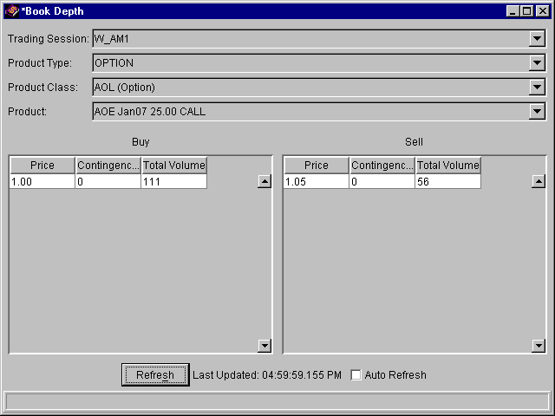

Number | Description | Expected Result | Expected Result Achieved?
1 | Open a Market Display Window  see Market Display | Market Display window opened
2 | Enter a Quote and several Orders (both BUY and SELL); all the SELL orders should have different prices, all of them higher than the Quote price; all the BUY orders should have different prices, all of them lower than the Quote amount (these Orders will therefore not trade)  See Quote Entry and Order Entry for details | Market Display table updates with latest (or best) Quote / Order amount
3 | Select Book Depth – Create New Window from the Start menu | Book Depth window opens
4 | Select the same Trading Session, Product Type, Product Class, and Product used in step 2. Click “Submit” | Resting Orders display on both Sell and Buy sides
5 | Select the “Auto Refresh” checkbox and go back to Market Display | Market Display reopens
6 | Hit the Bid or Take the Offer several times on the table row from step 2. | Resting Order entries disappear from Book Depth window as they are traded

Market History
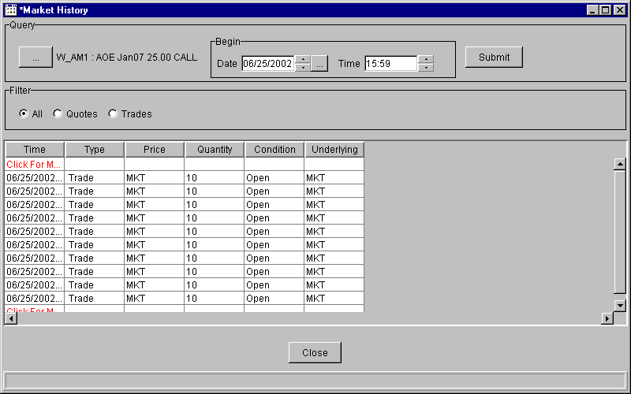

Number | Description | Expected Result | Expected Result Achieved?
1 | Open a Market Display Window  see Market Display | Market Display window opened
2 | Enter several Quotes and Orders that won’t be canceled by the system (they may trade, however).  See Quote Entry and Order Entry for details | Quotes and Orders display in Market Display
3 | Select Market History – Create New Window | Market History window opens
4 | Click the “…” button in Market History | Class/Product Selection dialog displays
5 | Select the Session, Product Class and Product you used in step 2, and click OK | Product displays to the right of “…” button
6 | Ensure the date and time are earlier than when you performed step 2, and click “Submit”  NOTE: You may also need to click the bottommost “Click For Row” red table cell in the table to display your trade data | Table displays all activity for the specified Product, bounded by tables rows with red labels saying “Click For More”.

Market Display

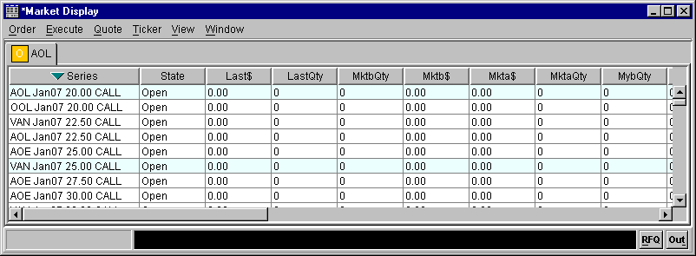
Figure 11 - Market Display

Add Class
Background Information
For each Market Display Window, the Trading Session, Product Type and Product Class will be empty the first time the window is opened. Once a value is selected, it will be remembered for the same Market Display Window. The Trading Session and Product Type can be saved as defaults for future sessions by selecting the “Set as Default” check box. The saved values are selected by default in the current and future sessions. The Trading Session and Product Type default values are saved independently of Market Display Window saved configurations.
Although the saved defaults can be changed at any time, they cannot be removed.

When selecting the Trading Session, Product Type and Product Class, the following considerations must be taken into account.
The Product Class combo box will include both Classes and Reporting Classes.
The Trading Session, Product Type and Product Class can be selected by using the mouse, or by typing the name of the session, product type or product class on their respective combo boxes.

Depending on the configuration and user preferences the tab will either be added (or selected if it exists) or the single tab will be replaced with the current Product class. See Miscellaneous Preferences.

Number | Description | Expected Results | Expected Results Achieved?
 | From the Menu Bar, Select View | View menu appears.
 | From the View menu, select Add Class.  Or use F9. | Add Class window appears.
 | Select a Trading Session, Product Type, and Product Class.
 | Press “Add Tab” | The window will close and a class tab for the selected class will appear in the Market Display Window.  Depending on the system configuration and user preferences, when “Add Tab” is pressed, existing class tabs might replaced with the selected Product Class.
Table 1 Adding a Class to the Market Display Window

Number | Description | Expected Results | Expected Results Achieved?
 | Follow the procedure to add a class to the Market Display Window (see Table 1 Adding a Class to the Market Display Window), but do not press “Add Tab” | Add Class window with Trading Session, Product Type and Product Class selected.
 | Check the “Set as Default” check box to make it selected. | “Set as Default” is selected
 | Press “Add Tab” | The Trading Session and Product Type selection is saved for future use. Note that the Product Class selection is not saved.  The window will close and a class tab for the selected class will appear in the Market Display Window.  Based on the system configuration, when a “Add Tab” is pressed, any existing class tabs might be removed.
 | Follow the procedure to add a class to the Market Display Window (see Table 1 Adding a Class to the Market Display Window), but do not press “Add Tab” | The Trading Session and Product Type combo boxes will show the saved default values.
 | Press the “Close” button. | The window will close and no class will be added to the Market Display Window.
Table 2 Setting a default Trading Session and Product Type for the Add Class window

At The Money
In the process of adding a tab (see Add Tab) to the Market Display Window, the “At the Money” series is calculated and selected in the class tab for the selected Product Class.
To determine the ATM, the following pre-conditions must be met:
- The ticker data must be available from the server.
- The current price for the underlying product for the selected Product Class has to be available from the server.
- The product type for the selected class must be Option.
Only if the conditions to calculate ATM are met (outlined above), the calculation is performed.
When the Market Display window opens, the selected series will be the closest to the “At the money” series.
If the selected class in the “Add Tab” window is a reporting class, the ATM calculation will only take into account those series that belong to the reporting class.
Note that this could mean that the selected series strike price might not be close to the underlying price, but it shall be the closest within the series for the selected reporting class.
If the selected class in the “Add Tab” window is not a reporting class, then the ATM calculation will take into account all the products for the class, regardless of the reporting class.
The selected series will be the closest to the “At the money” series.

The “At the Money” series can be explicitly selected for the selected Product Class in the Market Display Window by pressing F11, or selecting “At the Money” from the View menu, or performing a right-click on the table for the selected class on the Market Display Window and selecting “At the Money” from the View menu.
The same conditions outlined above also apply to this action.
If the ATM series cannot be calculated, the selection will not change.
If the ATM can be calculated, the series that is closest to the “At the money” series will be selected.
When requesting the ATM series explicitly all series in the class will be taken into account to determine the ATM series.
The “At the money” menu option is enabled for Option product types only.

Number | Description | Expected Results | Expected Results Achieved?
 | Add a class tab for an Option product as described in Table 1 Adding a Class to the Market Display Window. | An option class is added to the Market Display Window.  The series with the strike price closest to the underlying price will be selected.  If the ATM cannot be calculated (usually when no ticker data is available) no series is selected.
Table 3 Verifying “At the Money” series is selected upon adding a Class to the Market Display Window

Number | Description | Expected Results | Expected Results Achieved?
 | Add a class tab for an Option product and selecting a Reporting class as described in Table 1 Adding a Class to the Market Display Window | The option class is added to the Market Display Window.  The series within the reporting class products with the strike price closest to the underlying price will be selected.  If the ATM cannot be calculated (usually when no ticker data is available) no series is selected.
Table 4 Verifying “At the Money” series is selected upon adding a Class to the Market Display Window for a Reporting Class

Number | Description | Expected Results | Expected Results Achieved?
 | Add a class tab for an Option product as described in Table 1 Adding a Class to the Market Display Window | The option class is added to the Market Display Window.  The series within the reporting class products with the strike price closest to the underlying price will be selected.  If the ATM cannot be calculated (usually when no ticker data is available) no series is selected.
 | Select the View menu. | The View menu is displayed.
 | Select the At the Money option, or press F11. | The “At the Money” option is calculated and selected. The series with the strike price closest to the underlying price will be selected. If the ATM cannot be calculated, the selection will not change.
Table 5 Selecting “At the Money” series from the Market Display Window

Table Views
Background Information
Depending on the product type, the Market Display Window can display market data with one or one of two different views. Market data for Option products can be displayed with the Single Row view or the Side by Side view. Market data for all other product types can only be displayed using the Single Row view. The menu option for Side by Side view is disabled for all product types except Option products.
By default the Side by Side view shows the Call product to the left of the Series column and the Put product to the right of the Series column.
Every 5th row is shaded with a background color other than white. The background color is set to a light blue color, but the color could change depending on the color depth of the PC’s video card.
The market data table font can be changed as necessary for each class tab. The font setting is independent for each class tab, so changing the setting in one tab will not affect other tabs. Two quick methods to change the font size are provided.
To increase the font for the table, press F8, or select the View/Table/Grow menu item.
The table font shall increase a point size. The maximum point size is 72. After reaching 72 points, the font will not grow any more.
To decrease the font for the table, press F7, or select the View/Table/Shrink menu item.
The table font shall decrease a point size. The minimum point size is 8. After reaching 9 points, the font will not shrink any more.
Each tab can have its own font size.
The table font size is saved with the window configuration, so it will be restored when a saved window is opened.
To change the font family, and/or style, use the Table Preferences.

Number | Description | Expected Results | Expected Results Achieved?
 | Add a class tab for an Option product as described in Table 1 Adding a Class to the Market Display Window | The option class is added to the Market Display Window.
 | Select the View menu. | The View menu is displayed.
 | Select the Table option | The Table sub menu is displayed.
 | Select the Grow option, or press F8. | The table font size is increased one point.
 | Continue pressing F8, or selecting Grow from the View/Table menu. | The font will continue growing until it reaches 72 points. After the point size reaches 72 points, the size will not grow any more.
Table 6 Making the font larger on the Market Display Window

Number | Description | Expected Results | Expected Results Achieved?
 | Add a class tab for an Option product as described in Table 1 Adding a Class to the Market Display Window | The option class is added to the Market Display Window.
 | Select the View menu. | The View menu is displayed.
 | Select the Table option | The Table sub menu is displayed.
 | Select the Shrink option, or press F7. | The table font size is decreased one point.
 | Continue pressing F7, or selecting Shrink from the View/Table menu. | The font will continue shrinking until it reaches 9 points. After the point size reaches 9 points, the size will not shrink any more.
 | Select a second class tab. | The font on the second class tab is not changed to be the same as the first class where the font changes took place.  If a second class tab is not available, add a new class tab using the procedure described in Table 1 Adding a Class to the Market Display Window.
 | Select the first class tab. | The font on the first class tab is the same point size as it was set before selecting the second class tab.
Table 7 Making the font smaller on the Market Display Window

Number | Description | Expected Results | Expected Results Achieved?
 | Add a class tab for an Option product as described in Table 1 Adding a Class to the Market Display Window | The option class is added to the Market Display Window.
 | Select the View menu. | The View menu is displayed.
 | Select the Table option | The Table sub menu is displayed.
 | Select the Edit Preferences option. | The table preferences window is displayed.
 | Select the Display tab. | A font selector pre-selected with the current table’s font is displayed.
 | Change the font name, size and style. | The preview font changes as the name, size or style is changed.
 | When satisfied with the changes, press Ok. | The table preferences window is closed and the selected font is applied to the current table.
Table 8 Changing the default font for a class

Multiple Class Tabs
The tests specified in this section depend on the Multiple Class Tabs setting being unlocked. To verify if the Multiple Class Tabs setting is unlocked and can be changed by the user, go to the Miscellaneous Preferences window and verify that the Multiple Class Tabs setting is enabled. If it is disabled (grayed out), the feature is locked and cannot be changed by the user. If the check box is selected, then Multiple Class Tabs are allowed. If the check box is not selected, then Multiple Class Tabs are not allowed.
If the feature is locked, it can be unlocked by modifying the SBTTraderGui.properties file, located on the “etc” directory of the Trader installation as follows:
- Exit the Trader application before trying to modify the properties file. The file is overwritten when Trader exits, so any changes made while the application is running will be lost.
- Find the <>LockMultiClassTabs property in the “Defaults” section.
- Set its value to false.
- Find the <>DefaultMultiClassTabs property in the “Defaults” section.
- Set its value to true.
- Save the file.
- Login to Trader normally
- Verify that Multiple Class Tabs is not locked (see previous paragraph for details).

Number | Description | Expected Results | Expected Results Achieved?
 | Open a Market Display Window. | Market Display Window is opened.
 | Select the View menu. | The View menu is displayed. Verify that the Multiple Class Tabs is checked.
 | Add a class for any product type as described in Table 1 Adding a Class to the Market Display Window | The product class is added to the Market Display Window.
 | Add a second class for any product type as described in Table 1 Adding a Class to the Market Display Window | The product class is added to the Market Display Window.  The Market Display Window shows two class tabs.
 | Select the View menu. | The View menu is displayed.
 | Select the Multiple Class Tabs option. | This will disable Multiple Class Tabs for this Market Display Window.
 | Select the View menu. | The Multiple Class Tabs option is not checked.
 | Add a third class for any product type as described in Table 1 Adding a Class to the Market Display Window | The first two class tabs are removed and only one class tab remains with the newly selected class.
Table 9 Changing from multi class tabs to single class tabs.

Single Row View

Number | Description | Expected Results | Expected Results Achieved?
 | Add a class tab for a non Option product as described in Table 1 Adding a Class to the Market Display Window | The class is added to the Market Display Window.
 | Select the View menu. | The View menu is displayed.
 | Select the Table option | The Table sub menu is displayed.
 | Select the <> option | The Single Row option is selected and the Side by Side option is disabled.
Table 10 Verifying the Table View options for non-option product types.

Number | Description | Expected Results | Expected Results Achieved?
 | Add a class tab for an Option product as described in Table 1 Adding a Class to the Market Display Window | The class is added to the Market Display Window.  The view is set to Side by Side with the series column visible on screen.
 | Select the View menu. | The View menu is displayed.
 | Select the Table option | The Table sub menu is displayed.
 | Select the <> option | The Side by Side option is selected and the Single Row option is enabled.
 | Select the Single Row option. | The view changes to Single Row.  If a product is selected when the view type is changed, the selection will be lost.
 | Select the Side by Side view from the View/Table/<> menu. | The view will change back to Side by Side.
Table 11 Verifying the Table View options for option product types.

Side by Side View
The Side by Side view shows the product series in the middle column. Left clicking on the series column and any columns to the left of the series will select the Call product for the series. Left clicking on any column on the right side (but not including) of the series column will select the Put product for the series.
The default columns for the side by side view have been reduced to maximize the use of screen real estate. The default columns are:
Column Name | Call Product Identifier | Put Product Identifier
Product State | cState | pState
Last Sale Price | cLast$ | pLast$
Last Sale Quantity | cQty | pQty
NBBO Bid Quantity | cNbQty | pNbQty
NBBO Bid Price | cNb$ | pNb$
NBBO Bid Exchange | cNbExch | pNbExch
NBBO Ask Quantity | cNaQty | pNaQty
NBBO Ask Price | cNa$ | pNa$
NBBO Ask Exchange | cNaExch | pNExch
Market Bid Quantity | cMktbQty | pMktbQty
Market Bid Price | cMktb$ | pMktb$
Market Ask Quantity | cMktaQty | pMktaQty
Market Ask Price | cMkta$ | pMkta$
Product Series | Series* | Series*
Table 12 Side by Side View Default Columns
* = There’s only one column called Series.
Select “Show All Columns” from the View/Table menu to see all columns.
Columns that are not part of the selected columns set, will be grayed out.
Select “Show Selected Columns” from the View/Table menu to see only the selected columns.
The “Show All Columns” and “Show Selected Columns” operations apply to both the Side by Side and Single Row views.

Other columns are available in the table preferences window. The table preferences window is launched from the View/Table/Edit Preferences menu item.

Click on the “cMktbQty” or “cMktb$” column to show the “Hit the Bid” window for the Call product.
Click on the “cMktaQty” or “cMkta$” column to show the “Take the Offer” window for the Call product.
Click on the “pMktbQty” or “pMktb$” column to show the “Hit the Bid” for the Put product.
Click on the “pMktaQty” or “pMkta$” column to show the “Take the Offer” window for the Put product.
Click on the “cNbQty”, “cNb$” or “cNbExch” column to show the “Hit the NBBO Bid” window for the Call product.
Click on the “pNbQty”, “pNb$” or “pNbExch” column to show the “Hit the NBBO Bid” window for the Put product.
Click on the “cNaQty”, “cNa$” or “cNaExch” column to show the “Take the NBBO Offer” window for the Call product.
Click on the “pNaQty”, “pNa$” or “pNaExch” column to show the “Take the NBBO Offer” window for the Put product.
To “Hit the Bid” for the currently selected product (Call or Put depending on where you have clicked before) quickly, use the accelerator keys “Control-Shift-B”
To “Take the Offer” for the currently selected product (Call or Put depending on where you have clicked before) quickly, use the accelerator keys “Control-Shift-O”
To “Hit the NBBO Bid” for the currently selected product (Call or Put depending on where you have clicked before) quickly, use the accelerator keys “Control-Shift-H”
To “Take the NBBO Offer” for the currently selected product (Call or Put depending on where you have clicked before) quickly, use the accelerator keys “Control-Shift-T”
When the appropriate window shows up, some of the parameters might be entered for you already (see Miscellaneous Preferences). When satisfied with the order parameters, click Submit. Based on your preference settings, you might have to confirm the order. If prompted for confirmation, press the “Confirm” button to send the order, or “Cancel” to not send it. The order submission can be canceled by pressing the “Cancel” button at any time after the Order window comes up. This cancel operation is NOT to be confused with an Order Cancel operation. When pressing the “Cancel” button the order is NOT sent to the server, so there is no order to cancel, but you are only canceling the operation that would send the order to the server. To cancel an order that was already submitted to the server see <ORDER_STATUS>.

Add Tab
To add a tab press F9 to display the Market Display Add Class
Select the appropriate Trading Session, then Product Type and finally the Product Class.
When satisfied press the “Add Tab” button.

Depending on the configuration and user preferences the tab will either be added (or selected if it exists) or the single tab will be replaced with the current Product class. See Miscellaneous Preferences

Selecting a Product
To select a product simply left click on the row that contains the desired product.

For Side-by-Side select the appropriate column for call or put. By default the Calls are on the left the series in the middle and the Puts on the right.

Market Display Add Class
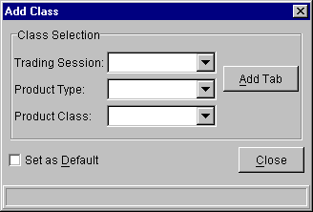
Figure 12 - Add Class

Ticker
The Market Display Window shows the ticker in the status bar.
Make sure the ticker is enabled in the preferences file located in the trader GUI installation’s etc directory. If the GUI is installed in c:\cboedirect\trader, then the file would be c:\cboedirect\trader\etc\SbtTraderGui.properties. The TickOn property of the Ticker section must be set to true.
The ticker on the status bar can be switched between ticker and recap. To change from ticker to recap or vice versa, right click on the ticker and select the appropriate option. The ticker can also be changed by selecting the appropriate option on the Ticker menu.
The ticker is also available in a stand-alone window. To start the ticker in a stand-alone window, select Ticker Display/Create New Window form the Start button on the Main Window. A new independent ticker window will appear. Both the ticker and recap are shown on this window. To change the ticker preferences, right click on the ticker window and change the preferences. Click Submit when satisfied with the changes. The changes are applied immediately to the open Ticker Window. The newly created Ticker window does not show the ticker for any class by default. To select a class, click on the product selector button (labeled “…”) and select a product class. The ticker and recap for the class will be shown on the ticker window.
If the ticker is not available from the server, a message will be shown indicating so.

Simple Ticker in Market Display:
- Start up Trader application
- Bring up an empty Market Display window by selecting “Market Display” – “Create New Market Display” from the “Start” menu
- Select any class to display (class most often used: AOE, W_AM1 session)
- Verify that ticker data displays correctly at the bottom of the window

Ticker vs Recap:
- Repeat steps 1 thru 3 of “Simple Ticker in Market Display”, above
- Right-click on the ticker, and select “Recap” from the pop-up menu
- Verify that Recap data displays correctly

Settings Dialogs
- Repeat steps 1 thru 3 of “Simple Ticker in Market Display”, above
- Right-click on the ticker, and select “Ticker” from the pop-up menu (it may already be selected)
- Right-click on the ticker, and select “Edit Preferences…”
- A dialog box with the Ticker checkboxes displays (6 checkboxes)
- Select and de-select checkboxes as desired, and verify this has the correct effect on the ticker (after clicking Submit in the dialog)
- Right-click on the ticker, and select “Recap” from the pop-up menu
- Right-click on the ticker again, and select “Edit Preferences…”
- A dialog box with the Recap checkboxes displays (16 checkboxes)
- Select and de-select checkboxes as desired, and verify this has the correct effect on the ticker (after clicking Submit in the dialog)

Other Ticker Tests

Changing Colors Using Swatches
- Repeat steps 1 thru 3 of “Simple Ticker in Market Display”, above
- Right-click on the ticker, and select “Edit Preferences…” from the pop-up menu
- Click on the “Display” tab
- Click on any color in the color selector in the “Swatches” tab
- Click “Submit”. The button should turn red and change to “Confirm”
- Click the “Confirm” button
- Verify that the ticker text changes to the selected color

Changing Colors Using HSB Selectors
- Repeat steps 1 thru 3 of “Simple Ticker in Market Display”, above
- Right-click on the ticker, and select “Edit Preferences…” from the pop-up menu
- Click on the “Display” tab
- Click on the “HSB” tab within the “Display” tab
- Change the values within the H, S, and/or B spinners, and/or move the color slider up or down, to change the selected color
- Click “Submit”. The button should turn red and change to “Confirm”
- Click the “Confirm” button
- Verify that the ticker text changes to the selected color

Changing Colors Using RGB Selectors
- Repeat steps 1 thru 3 of “Simple Ticker in Market Display”, above
- Right-click on the ticker, and select “Edit Preferences…” from the pop-up menu
- Click on the “Display” tab
- Click on the “RGB” tab within the “Display” tab
- Change the values within the R, G, and/or B spinners, and/or move the R, G, and/or B sliders left or right, to change the selected color
- Click “Submit”. The button should turn red and change to “Confirm”
- Click the “Confirm” button
- Verify that the ticker text changes to the selected color

Changing Fonts
- Repeat steps 1 thru 3 of “Simple Ticker in Market Display”, above
- Right-click on the ticker, and select “Edit Preferences…” from the pop-up menu
- Click on the “Display” tab
- Select a different font, size, and/or style from the dropdowns at the top of the dialog
- Click “Submit”. The button should turn red and change to “Confirm”
- Click the “Confirm” button
- Verify that the ticker text changes to the selected font

Saving Market Display Ticker Configuration
- Repeat one of the above “Changing Colors” tests and the above “Changing Fonts” test. Make sure your color/font change is substantially different from the default. Mark down (or remember) your selected font/color combination
- Right-click on the Market Display button in the Task Toolbar
- Select “Save Configuration” from the pop-up menu
- Give your configuration a name you will remember
- Click “Submit”. The button should turn red and change to “Confirm”
- Click the “Confirm” button
- Shut down and restart the Trader application
- Login again to Trader using same username/password
- Select “Market Display” from the Start menu. Your saved configuration should display in the submenu at right
- Select the saved configuration.
- Verify that your saved Market Display window – including the class, window size, and font/color of the ticker, all redisplay as you saved them. NOTE: It may take a few seconds for the window to load and display

Simple Standalone Ticker Display
- Start up Trader application
- Bring up an empty Ticker Display window by selecting “Ticker Display” – “Create New Window” from the “Start” menu
- Click on the “…” button to bring up the Class Selector dialog
- Select a Trading Session, Product Type, and Class. Click OK.
- Verify that the selected product displays in the Ticker Display window

Standalone Ticker Settings and Configurations
- Repeat “Simple Standalone Ticker Display” test, above
- Repeat “Changing Colors Using RGB Selectors” and “Changing Fonts”, above, using the Ticker Display’s ticker. NOTE: The right-click pop-up menu that displays will only contain the one item, “Edit Preferences”
- Repeat “Saving Market Display Ticker Configuration” from steps 2 forward, substituting the standalone Ticker Display window for the Market Display

SBT Ticker Correctness compared with other Tickers
There is some debate as to the speed of the SBT ticker compared to other tickers – CBOE and non CBOE based. I would not rely on the speed of the ticker scrolling and consider the accuracy and timeliness of the data.

The current SBT implementation uses a queue like mechanism for storing data that has not yet been displayed. Currently the queue size is one. This effectively means that if the client is receiving data more quickly than can be displayed, it will replace the old data with new data.

SBT Ticker Performance

Status Window
The Status Window is only accessible as a stand alone window.
To open a Status Window, go to the Main Window’s Start Menu, select Status Window and click the “Status Window” sub menu. A new Status Window will appear.
To view the details of a status report, double click on the report, or perform a single left click and select Details from the Status menu.
To print the details of a status report, open the details and select the print button, or perform single left click and select Print from the Status menu.
A Print dialog will appear with the print options can be changed. When you are satisfied with the options, select “OK” to print or “Cancel” to exit the Print dialog.
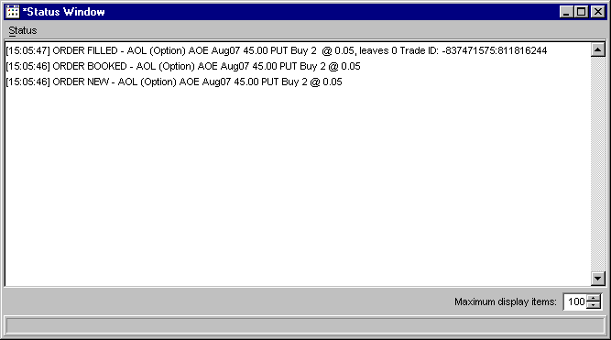

Order Status
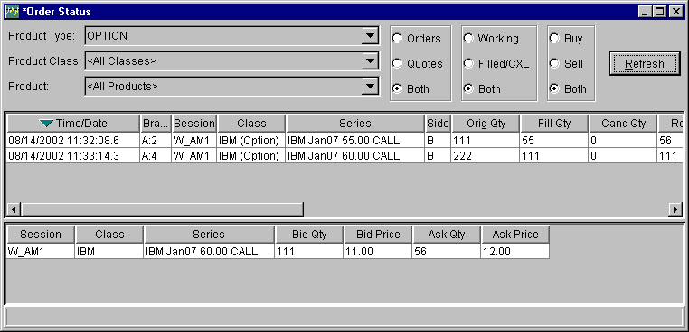
Figure 13 - Order Status

Number | Description | Expected Result | Expected Result Achieved?
1 | Open a Market Display Window  see Market Display | Market Display window opened
2 | Enter several Quotes and Orders that won’t be canceled by the system (they may trade, however); note that these do not need to be in the same series, or even the same class  See Quote Entry and Order Entry for details | Quotes and Orders display in Market Display
3 | Select Order Status – Create New Window | Order Status window opens
4 | Select Product Type OPTION, Product Class <All Classes>, Product <All Products>, and click “Refresh”. | All filled and resting Orders should appear in the top table; all unfilled Quotes should appear in the bottom table

Order Operations

Cancel Order

Number | Description | Expected Result | Expected Result Achieved?
1 | Repeat Order Status test, above | See above
2 | Right-click on a row in the top table (representing a filled Order), and select Cancel Order. | Cancel Order dialog displays
3 | Review the order information in the Cancel Order dialog; you will need to enter a quantity equal to or less than the full order amount (try values around the full amount, including above it, to test this) then click “Submit” | Order should disappear from Order Status

Cancel Replace Order

Update Order

Order History

Number | Description | Expected Result | Expected Result Achieved?
1 | Repeat Order Status test, above | See above
2 | Right-click on a row in the top table (representing a filled Order), and select Order History. | Order History window displays, with in-depth data for the selected order

Preferences

User Preference Overview
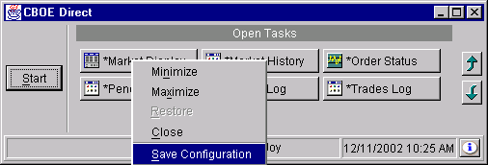

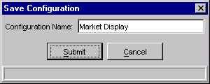

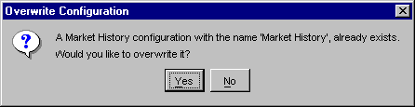

The following have preferences that can be named and saved by the user:

Activity Log
Book Depth
Held Order Status
Market Display
Market History
Order Status
Pending Price Adjustments
Pending RFQs
Status Window
Ticker Display
Trades Log

The preferences are context specific, but most all save the following at a minimum:

Window Preferences:
Window Size
Window Position on screen
Font

If the Frame contains other controls that have preferences they too will be saved.
Here is a list of controls and their preferences:

Table

Split Pane

Product Selectors (Market History, Order Status, Ticker Display, Trades Log)

Tabs (Market Display, Held Order Status)

Filter Controls (Market History, Order Status)

Default Preferences Template

Description of Enhancement

A user requested new functionality to set up a market display with columns that they want, choose an “apply to all” button, and thereafter all market display windows should come up that way. The implemented solution generalized the request somewhat and puts in place a new concept of a persistent preferences template to use as a default for all new windows of the same type as the template saved by the user. For example, after saving a Market Display default preferences template, all new market display windows will come up with these preferences applied. If an Order Status default preferences template is created, this set of preferences will be applied to all new Order Status windows.

For the Market Display window, this set of default preferences includes not only which columns have been selected, but also all other Market Display window and table preferences so that attributes such as font, column order, sort order, etc. can also be propagated into new Market Display window tabs. In order for this to be plain to the user, the concept of an “Apply to All” button as originally requested was changed. Instead, the GUI presents to the user the choice to save a default preferences template via the Save Configuration dialog (obtained by right-clicking on the window’s icon in the CBOE Direct main window):

Previous Save Configuration Dialog

A new Save Configuration dialog will offer the choice of saving a named window configuration or a default preferences template for that type of window:

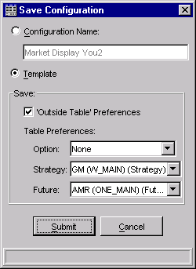
Example Market Display Save Configuration Dialog

The ”Template” save portion of the Save Configuration window may vary depending on the type of window. The example above depicts the Save Configuration window for the Market Display with the “Template” radio button chosen. The first choice of saving a named configuration works exactly as it previously did. The new choice of saving a template of default preferences for the Market Display will allow the user to tailor which subsets of default template preferences are saved:

- “Outside Table” preferences - If checked, the window preferences for Market Display window will be saved. The term “outside table” is intended to be more intuitively meaningful to the user than the term window preferences. These window preferences include the window’s size, location, window default font, and all the ticker display preferences. Testing for this functionality should include verifying that new market display windows come up with the correct screen position, window size, ticker color and font, etc. (See checklist below.)
- Table preferences combo boxes – These will vary depending on the number and type of tabs that exist in the Market Display window. For example, if there are no strategy tabs present, the strategy choice will not appear. If there are existing tabs for a product type, the “None” choice also appears so the user can abstain from saving a preferences template for that product type.

Initially the Configuration Name radio button is selected and the template portion is not visible in order to present equivalent upwards compatibility with the current familiar behavior of CBOE Direct.

If the user selects the “Template” radio box, then the Market Display’s Save Configuration dialog immediately grows larger, displaying the choices show above. The “Outside Table” Preferences checkbox is checked by default, and each product type combo box is enabled for the user’s choices.

Once the user is satisfied with his choices, the Submit button can be pressed. That button turns into a Confirm button (as it previously did), and once that is pressed, the named configuration or default preferences template will be saved. Note that the user cannot set the name of the preferences template, since only one default preferences template exists and is saved per window. Any consequent saving of a default preference template overwrites the currently saved template (after appropriately warning the user and allowing them to cancel the overwriting). The Cancel button of the Save Configuration dialog also allows the user to exit the dialog without saving any preferences.

For windows other than Market Display, the Save Configuration dialog is much simpler. For this initial release, windows other than Market Display will not present any choices for subsets of default template preferences:

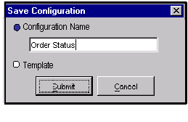
Order Status Save Configuration dialog

For the convenience of the user, a default preferences template (if one exists) can be applied to a window that has already been created. All the user needs to do is right-click on the window’s icon in the CBOE Direct main window and select “Apply Default Preferences.”

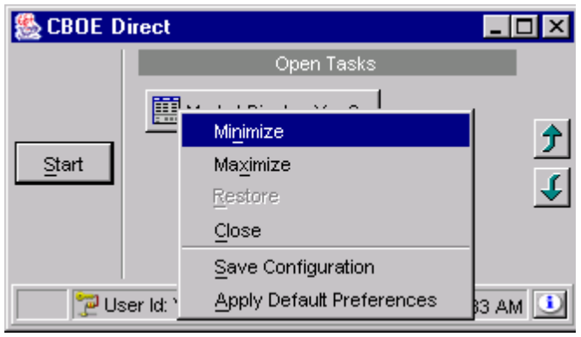
New “Apply Default Preferences” Menu Item

Testing Areas

Testing should be performed on most, but not all, windows that can be created from the Start Menu. The windows in the Trader GUI that support a default preferences template and should be tested are:

Activity Log
Book Depth
Held Order Status
Market Display
Market History
Order Status
Pending Price Adjustments
Pending RFQ
Status Window
Ticker Display
Trades Log

The windows in the SA GUI that support a default preferences template and should be tested are:

Book Depth
Message Center
Price Adjustments
Product Class Groups
Product Definition
Product Descriptions
Product Settlement and Open Interest
Product State Maintenance
Session Browser
Block Trade Entry
Trade Bust
Trade Query
Trading Session Management
User Management

The Market Display window has a more specific implementation than the other SBT windows because of its product tabs, and so it will require additional testing over and above that needed for the other windows. For all windows, no specific product and/or product class is saved in the preferences template. The idea was not to put up specific windows (i.e. not like a Named Configuration), but rather to control the GUI appearance and window setup for the user independent of the actual product class he is looking at. For example, with the Market Display window, when a new MD window is created, it will be created with the size and position that was saved in its default preferences template (i.e. the “outside table preferences), if a template exists. However, the window will come up empty, without any product/class, as it did previously. Once the user adds a class (e.g. via the F9 key), the tab that is displayed for that class will have the default preferences that pertain to that product type applied to the table in the tab.

While testing this new feature, you will exercise the functionality of the Edit Column Preferences window, which allows the user to specify which columns are visible, the order in which these are displayed, and the font used within the table. This dialog works independently of the new preferences template, and you may see bugs that have already been entered into DDTS for this window (and perhaps some that haven’t been entered). Once you have a Market Display or other window the way you want it, and ask for that window to be used to create a default preferences template, then any new window you create or a window that you ask to have the template applied to should then be checked to make sure it is set up the way you expect it to be. Any bugs found in those areas should be logged as preferences template bugs. Since these preference templates are saved between user sessions, subsequent invocations of CBOE Direct by the same user will also have default templates automatically applied to any new windows created, and this functionality should also be tested.

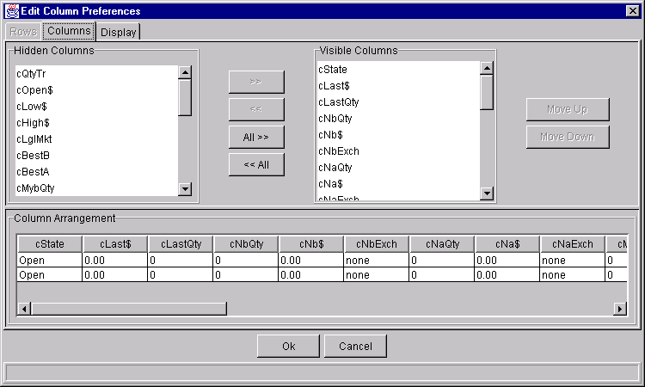
Edit Column Preferences window

It is also important to test that windows created from Named Configurations work exactly as they did previously, since these already have their own set of saved preferences and should be totally unaffected by any saved default preferences template - unless the user specifically asks for the preferences template to be applied to the window. In this case, the preference changes in the named configuration will not be persisted (i.e. saved) unless the user specifically saves the changed window as a named configuration once again.

The Market Display has two properties in the properties file that limit how many Market Display windows can be open at one time and how many tabs a Market Display window can have. All the testing described above for the Market Display window should be repeated with at least two different values for both of the properties. For example, when only one Market Display window is allowed at any one time, the user’s attempt to open another one results in the current one being re-used. This reuse does not apply the default preferences template because a new window is not created. A similar situation happens when a tab is reused. The limits in the two properties should be increased to test that both new tabs in existing windows and newly opened Market Display windows have the preferences template applied. Existing windows will only have the template applied to newly opened tabs. New windows should have the window characteristics of the new template (e.g. position, size, etc.) and their tabs when created should reflect the default template’s preferences. Since the code for the multiple window case is complicated, whenever a default template is created or removed, it is important to test with multiple windows open of the same type and also test the opening new windows. Check that the preferences used for the new windows and for any new tabs reflect the new default preferences template.

Whenever a new version of CBOE Direct is released, the application informs the user that the saved preferences need to be converted to the new release’s version and offers to do this automatically for the user. This preference conversion needs to be tested in the area of default template preferences to make sure this conversion works properly for these saved preferences.

A new Saved Configurations Maintenance panel can be invoked from the Start menu (via the “Preferences” submenu). This panel allows the user to convert both Named configurations and default template preferences from older versions of SBT to your current version by dragging and dropping the corresponding tree item. It will also remove a preference set, by right-clicking on the item and selecting “Remove.”

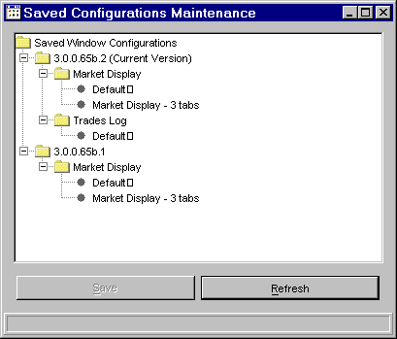

Changes you make will only take effect after being saved by pressing the Save button and confirming the save. Once a default preference template is deleted, any new windows of the same type (and new Market Display tabs, if a Market Display default was deleted) should appear as they did before the default template was created. Again, the single and multiple-window cases should be tested when a default template is deleted. Any named configurations deleted from the panel should no longer appear in the Start menu. These changes should be tested that they persist after exiting and restarting CBOEDirect. Similar testing with should be done with at least two other window types other than market display windows, checking the behavior of any windows opened after a default preferences template is deleted. The windows should look as they did before the template was created.

Auto Selection in Combo Boxes

Combo boxes allow selection of an item by using the mouse, or the keyboard. The combo box matches the textual representation of list items to typed characters. The best match is selected by examining the typed characters and selecting the first item that matches the typed text. Subsequent typed characters will be appended to continue refining the match in the list. The combo box will highlight the matched characters. Pressing backspace will clear the last selected character. If after pressing backspace there are no more matched (highlighted) characters, the first item in the list will be selected.
Some keys have special meaning. The HOME key will clear the current selection and select the first item in the list. The END key will clear the current selection and select the last item in the list. Pressing the UP key, will clear the selection and select the previous item in the list up to the first item in the list. Pressing the DOWN key will clear the selection and select the next item in the list, down to the last item in the list.
Regardless of the position in the list, if there are no current matches (nothing is highlighted), searches for a match will start at the top of the list. If there is a current match, indicated by a portion of the text for the current item being highlighted, subsequent characters will only be matched starting from the current position.

List Items:

AAA
ABY
DELL
IBM
OEX
YHO
YYY
ZZZ

Typing “I” will select IBM and highlight “I”. Typing “M” immediately after “I” will not make another selection, as there is nothing that starts with “IM”. Typing “B” will highlight “IB” and leave IBM selected. Pressing Backspace twice will clear the match. Pressing “D” now will select “DELL” and highlight “D”. Pressing HOME will select the first item and clear the highlight. Pressing “Y” will select “YHO” and highlight “Y”. Pressing “Y” again will select “YYY” and highlight “YY”. Pressing backspace will reset the selection back to “Y” which will make “YHO” selected again. Pressing “H” now will highlight “YH” and keep the selection on “YHO”.

Product Configuration Service

The PCS window is divided into two sections, a navigation tree on the left, and two lists and several buttons on the right. The navigation tree is used to select product class groups and group types, as well as to perform group manipulation operations. The lists on the right will show the available product classes to add to a group and the members of the group. This section of the screen is disabled until a product group is selected. Creation and modification of group types, groups and sub groups is only allowed in support mode. The default mode will only allow a user to view the PCS structure, but not to make any changes. To make changes, select “Support Mode” from the PCS window menu and enter the support password. This will enable menu options to create group types, create groups, remove sub groups, enable the drag and drop operations to add sub groups and will allow the “Apply” button to commit group changes to the server.

Initially only one node is displayed. When this node is expanded it will show the group types. When a group type is expanded it will show all its member groups. When the group node is expanded, it will show its sub groups, if any. Each sub group is also a group, and can contain sub groups. Sub groups can contain more sub groups as necessary, although special care must be taken to not create circular references.

When a group is selected, the right side of the screen will show the product classes for the group. Classes are added to a group by selecting them from the left side list (Available Items) and clicking the “Add Selected Items” button. The classes are moved to the right side list (Member Items) and removed from the available items list. To remove classes from a group, selected the classes in the member items list and press the “Remove Selected Items” button. To add ALL classes to the group, press the “Add All Items” button. To remove ALL classes from the group, press the “Remove All Items” button. To undo the previous operation, press the “Undo” button. The “Undo” button is only enabled before the changes are committed to the server. Once the changes are committed to the server by pressing the “Apply” button, they cannot be undone by pressing the “Undo” button. To undo changes after they have been committed to the server, perform the necessary add or remove operations and press “Apply” again.

Navigating the group types and groups
Step | Result | Notes
Select the root node and perform a single click | Request is sent to get all group types. | The operation can take a few seconds. (use glass pane)
Select a group type and perform a single click | Request is sent to get all groups for the group type. | The operation can take a few seconds (use glass pane)
Select a group and perform a single click | Request is sent to get all sub groups for the group. | The operation can take a few seconds (use glass pane).

Creating a group type
Step | Result | Notes
Select the root node and perform a right click. | Popup menu appears | The popup menus are context sensitive and only the options that can be performed for a particular node type are shown and enabled.
Select “Create Group Type” | Create Group Type dialog appears
Enter appropriate group type |  | The suggested group type is just one more than the maximum group type returned by the server. Group types do not have to be in sequential order.  If the group type is already in use, an error message will appear in the confirmation step.
Enter group type description |  | If the description is empty, the an error message will appear in the confirmation step.
Select exclusive membership value |  | If exclusive membership is selected, groups of this type cannot include classes that are included in other groups, even if the type of the other group does not have exclusive membership.
Alternate Steps B.1
Press Submit | The dialog requests confirmation
Press Confirm | A request is sent to the server to create a group type. . | If the server can create the group type, the dialog will be closed and a new group type node will be added to the tree. If the group type cannot be created and the server returns an error message, the error will be displayed.
Alternate Steps B.2
Press Cancel | The dialog is closed and the request to create the group type is not sent.

Creating a group
Step | Result | Notes
Select a group type node and perform a right click | Popup menu appears | The popup menu shall contain an option to create a group.
Select “Create Group” | Create Group dialog appears | The dialog will show the group type’s description and if it has exclusive membership.
Enter group name |  | The group name must be unique or it will not be accepted by the server
Alternate Steps B.1
Press Submit | The dialog requests confirmation
Press Confirm | A request is sent to the server to create a group. | If the server can create the group, the dialog will be closed and a new group type node will be added to the tree. If the group cannot be created and the server returns an error message, the error will be displayed.
Alternate Steps B.2
Press Cancel | The dialog is closed and the request to create the group is not sent.

Adding sub groups
Step | Result | Notes
Select a group node that will be the sub group |  | Ensure that no circular references will be created when adding sub groups.
Initiate a Drag operation by left clicking on the node and simultaneously dragging it to the intended super group. | Cursor changes to a “Link” cursor | The “Link” cursor has a small arrow on the lower right corner.
Drop the group into the intended super group node. | A node is added to the super group to show the new sub group. | The sub group will only be added if the super group is not a sub group of the intended sub group, and if the sub group is not already a sub group of the super group.  Any group can be a super group or sub group of another group, even if they belong to different group types.

Removing a sub group from its super group
Step | Result | Notes
Select the sub group node

Perform a right click | Popup menu appears | If the selected node is not a sub group of any other group, the menu option to remove the sub group will be disabled
Select “Remove Sub Group” | The sub group is removed from the parent group | No confirmation is required for this operation.

Enabling Support Mode
Step | Result | Notes
Select the Window Menu

Select the Support Mode menu item | Support Mode dialog appears
Enter the support password |  | Password is CCC
Press Submit
Press Confirm | If the password is correct, the dialog is hidden, popup menu items are enabled, drag and drop is enabled, support mode menu item is disabled, buttons to add or remove items to a group are enabled, apply/undo get enabled after changes to the member list.

Strategies / Complex Orders
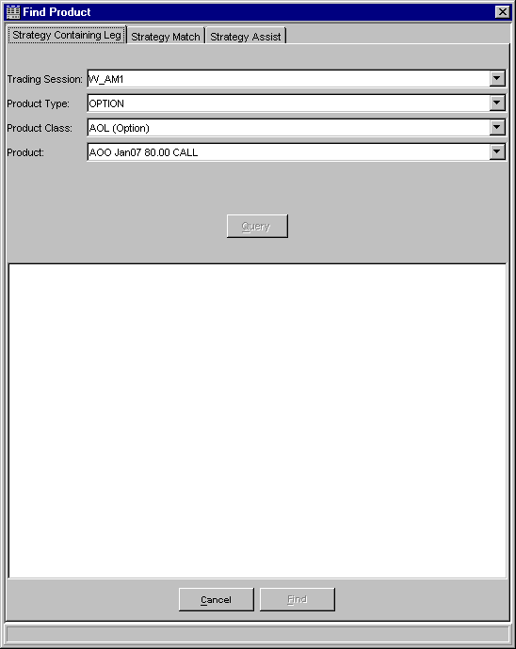
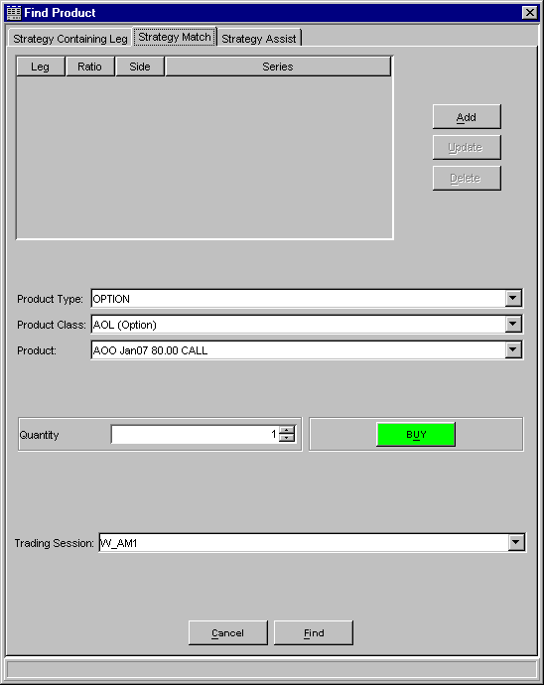

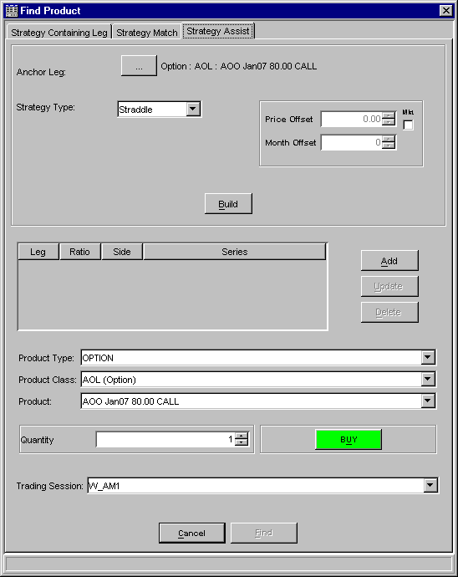

GUI Responsiveness
This is more subjective, but the feel of the application should be smooth. Long pauses (greater than a second) that are not indicated to the user (possible by a wait cursor and possibly a glass pane) should not occur.

The GUI interface should always be responsive to user input. Mouse movement and scrolling should be smooth and uninterrupted. Scrolling should be quick and responsive to scrolling stop actions. Dragging the scrollbar’s thumb should not slow down the application.

One windows actions should not slow down any of the others.

Any Windows based machines that have less than 20% of their physical memory available may experience “thrashing”- a condition in which the OS is spending significant amounts of CPU cycles managing memory. When the OS is thrashing it writes some portions of its physical memory to the hard drive because it doesn’t have enough physical memory. The OS then needs to access that memory and is forced to read that information from the disk back into memory, the cycle repeats as the other memory it just wrote to the hard drive needs to be referenced. There is nothing that the Java Virtual Machine can do to prevent this or correct it once it occurs. The solution may be to just have more physical memory on the PC, or shut down other unneeded programs.

SA GUI Test

Login

Number | Description | Expected Results | Expected Results Achieved?
 | Login to SA GUI using valid help desk ID. | Login Successful

Calendar Admin

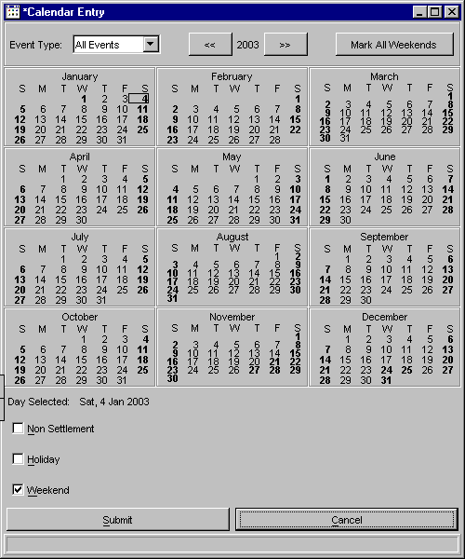
Figure 14 - Calendar Admin

Number | Description | Expected Results | Expected Results Achieved?
 | Select the “Calendar” option from the Start Menu | A window similar to the figure above appears
 | Select a day on the calendar that is not bold. | The bottom portion of the screen shows the Day Selected as the proper day and the check boxes show no events for the day selected.
 | Select one of the events for a day (Non Settlement, Holiday, Weekend) | The check box becomes selected and the day on the calendar changes to a red font.
 | Press Submit Button | The submit button changes to red and displays “Confirm”
 | Press Confirm Button | The information is sent to the server to save. The day on the calendar changes to a black bold font.
 | Remove the event that was just added to the day selected. | The font for the day on the calendar changes to red. The checkbox is no longer selected.
 | Press Submit Button | The submit button changes to red and displays “Confirm”
 | Press Confirm Button | The information is sent to the server to save. The day on the calendar changes to a normal black font.
 | Press the “>>” button to change the year. | Verify the year displayed is the next year. Verify the events are not on the same days. This is easy to verify by visually looking at the weekends and determining that Saturday and Sunday days are property bolded.
 | Press the “<<” button to change the year back | Verify the year is changed to one year previous and that the days are properly marked.
 | Change the “Event Type” filter drop down from “All Events” to “weekend” | Verify that all bold days contain an event for “Weekend”.
 | Change the “Event Type” filter drop down from “weekend” to “Holiday” | Verify that all bold days contain an event for “Holiday”.
 | Select a weekend day on the calendar that was previously bold | Verify that the check boxes still show the “Weekend” event even though the day is not bold on the calendar.
 | Change the “Event Type” filter drop down back to “All Events” | All days with events now become bold.
 | Remove all events from a year and save the changes | The calendar should have no bold days.
 | Press the “Mark All Weekends” button | Verify all weekend days are changed to bold and they all contain a single event for “Weekend”
 | Press the “Cancel” button | Verify all days are changed to normal font and all weekend days have no events.
 | Select “Calendar” from the start menu. | Verify two calendar windows are now open.
 | Modify one calendar and save changes. | Verify all changes made on one GUI are reflected in the other immediately.

Calendar Admin Notes
- A bold font on a day on the calendar means the day has events associated to it.
- A red font on a day means the day has been changed and not saved.

SA GUI Test

Login

Number | Description | Expected Results | Expected Results Achieved?
 | Login to SA GUI using valid help desk ID. | Login Successful

User Enablements

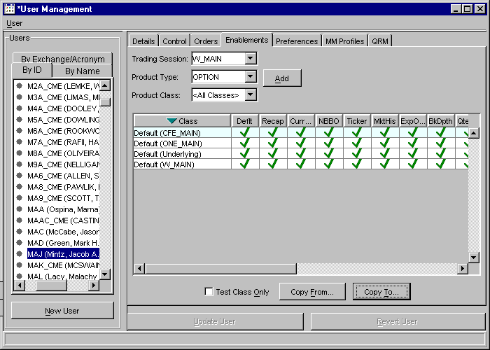
Figure 15 User Enablements

User Enablements Notes
- This test requires the use of 3 Market Maker userids. For the purpose of this test, the market maker users used were MAA, MAC and MAD. Any three users with a role of market maker can be substituted for them. The test plan will refer to these three ids by the Acronym, substitute the three acronyms in the test plan, if you use different ones.
- This test requires the use of 2 Help Desk userids. For the purpose of this test, the help desk users used were HD2 and HD3. Any two users with a role of help desk can be substituted for them. The test plan will refer to these two ids by the userid, substitute the two userids in the test plan, if you use different ones. The help desk users must have full enablements for all sessions.
- Sessions and classes may be different in each environment. Any session and/or Class can be substituted. Do not substitute the same session or class for two different sessions or classes in the same test.
- For the following tests, it is best to have two GUIs active, a SA GUI and a Trader GUI. Instructions for the SA GUI will be prefaced with [SA] and instructions for the Trader GUI will be prefixed with [Trader]. If the test does not contain any identification, the whole test is for the SA GUI.

1. Testing Basic Enablement GUI
Number | Description | Expected Results | Expected Results Achieved?
 | Select the “User Maintenance” option from the start menu | A window similar to the figure above appears
 | Select the user MAA in the user tree. | The panels on the right display the information for the selected user.
 | Select the Enablements tab | The enablements tab appears.
 | Select the Trading Session drop down and verify all sessions appear in the list | All sessions appear in the list
 | Select a session | The Product Type and Product Class combo boxes get default values. The Product Type will show a valid Product Type and the Product Class will show “<All Classes>”
 | Select a Product Class from the combo box that is not already in the enablement list. | Selected Product Class shows in the combo box.
 | Press the add button | The enablement for the Session and Class is added to the table. The “Update User” and “Revert User” buttons become enabled.
 | Press the “Revert User” button and press “Yes” on the confirmation dialog | The row is removed from the table and the Update and Revert buttons become disabled.
 | Press the add button to add the enablement. | The enablement for the Session and Class is added to the table. The Update and Revert buttons become enabled.
 | Press the “Update User” button | The user is updated and the screen switches back to the Details tab
 | Click the Enablements tab | The enablements tab appears. Verify the list of enablements contains the original list, plus the new enablement added.
 | Click on the new enablement to select the row in the table. | The row becomes highlighted
 | Right-Click on the selected row, which contains the new enablement | A Pop-Up menu appears with the options “Enable All”, “Invert Enablements” and “Remove”
 | Select “Remove” from the menu. | The row is removed from the table. The Update and Revert buttons are enabled
 | Press the “Revert User” button. | The row is added back into the table and the Update and Revert buttons are disabled
 | Select the new row, Right-Click and select “Remove” from the menu. | The row is removed from the table.
 | Select the “Update User” button | The enablements are saved and the tab switches to the details tab.
 | Select the Enablements tab. | Verify the new row is not contained in the table with the list of enablements
 | Double click on one of the cells in the table with a green check. | The green check changes to a red x. The Update and Revert buttons become activated.
 | Press the Update button, followed by Confirm | Verify the change is saved ant the cell is still unchecked.
 | Double click the cell with the red X | The red X changes to a green check. The Update and Revert buttons become active
 | Press the Update button followed by confirm. | Verify the change is saved and the cell is checked.
 | Select a row in the enablements table | Row is selected
 | Modify the row to contain some enablements on (red X) and some off (green check). | Selected row contains a mix of enablements
 | Right-Click on the row to bring up the pop-up menu | A Pop-Up menu appears with the options “Enable All”, “Invert Enablements” and “Remove”
 | Select “Invert Enablements” from the menu | Verify all the enablements were inverted for the selected row only.
 | Right-Click on the row to bring up the pop-up menu and select “Enable All” | Verify all the enablements were enabled for the selected row.
 | Select the user “MAC” in the user tree. | Dialog appears stating that you have unsaved changes and asking if you wish to save them.
 | Press the “Yes” button on the dialog. | Screen saves and switches to the new user
 | Select the user “MAA” in the user tree and select the enablements tab. | Verify the changes were saved.

Testing Enablement Copy GUI
Number | Description | Expected Results | Expected Results Achieved?
 | Edit the user MAA to have the following enablements and save the changes.  W_MAIN/AOL/all  W_MAIN/IBM/Deflt only  W_AM1/Default/all | User MAA shows the enablements
 | Edit the user MAC to have the following enablements and save the changes.  W_MAIN/IBM/all  W_AM1/DJX/all | User MAC shows the enablements
 | Select the user MAA | User MAA shows
 | On the enablements tab for MAA, select the Copy From button. | Copy Enablements From User dialog shows.  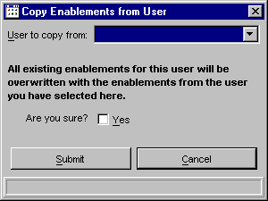
 | Type “MAC” in the “User to copy from” combo box.. | User MAC shows as selected in the combo box
 | Do Not select the confirmation check box and press the “Submit” button. | Dialog closes and enablements for user MAA remain unchanged.
 | Select the Copy From button | Copy enablements from user dialog shows
 | Select MAC from the dropdown in the combo box | User MAC shows as selected in the combo box
 | Select the “Yes” check box. | Check box shows a check in it
 | Press the submit button and press confirm | Dialog closes and user is taken back to the enablements tab, where the enablements have been changed to exactly what user MAC had. Verify from list above.
 | Edit the user MAD to have the following enablements and save the changes.  W_MAIN/Default/all  W_AM1/NDX/NBBO only | User MAD shows the enablements
 | Edit the user MAA to have the following enablements and save the changes.  W_MAIN/AOL/all  W_MAIN/IBM/Deflt only  W_AM1/Default/all | User MAA shows the enablements
 | Select the user MAD and go to the enablements tab | User MAD enablements show
 | Press the Copy To button. | Copy Enablements To Users dialog shows
 | Type MAC in the combo box | User MAC shows selected
 | Press the “Select >” button | User MAC shows in the “Users Selected” list box
 | Select MAA from the Users combo box | User MAA shows selected
 | Press the “Select <” button | User MAA shows in the Users Selected list box
 | Do Not check the “Yes” confirmation checkbox and press Submit, then Confirm | Dialog closes and takes the user back to the enablements screen for MAD. Select the users MAC and MAA and verify no changes.
 | Press the Copy To button. | Copy Enablements To Users dialog shows  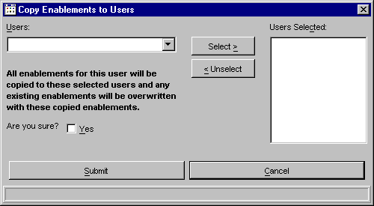
 | Type MAC in the combo box | User MAC shows selected
 | Press the “Select >” button | User MAC shows in the “Users Selected” list box
 | Select MAA from the Users combo box | User MAA shows selected
 | Press the “Select <” button | User MAA shows in the Users Selected list box
 | Check the “Yes” confirmation checkbox | Yes confirmation check box has a check in it.
 | Press the Submit button, then Confirm | Dialog closes and copy to report dialog opens.  Verify new Enablements are listed for MAD.  Verify old enablements are listed for MAA and MAC and they are correct.
 | Select the enablements tab for user MAA and MAC | Verify the enablements are the enablements from MAD
 | Start up a second SA GUI and log in as a different help desk user. | Logged in
 | Select “User Management” from the start menu | User Management opens
 | Select the user MAA and select the enablements tab. | User MAA is shown
 | Add the enablement W_MAIN/ORCL/all  Do not save. | The enablements shows on the table
 | Back on the first GUI, select the user MAA and select the enablements tab. | User MAA shows without the new enablement
 | Still on the first GUI, add the enablement W_MAIN/AMD/all | The enablement shows on the table
 | Still on the first GUI, press “Update User” | The enablements save and the GUI switches back to the details tab
 | Still on the first GUI, select the enablements tab | The enablements tab shows only W_MAIN/AMD added.
 | View the second GUI. | A dialog has appeared on the second GUI notifying the user that changes were made.
 | On the second GUI, select the enablements tab | The list of enablements is identical to the list on the first GUI
 | For the following tests, it is best to have two GUIs active, a SA GUI and a Trader GUI. Instructions for the SA GUI will be prefaced with [SA] and instructions for the Trader GUI will be prefixed with [Trader]

Testing Enablements
Number | Description | Expected Results | Expected Results Achieved?
 | [SA] Login to the SA GUI with a help desk userid and start User Management | User Management window appears.
 | [SA] Setup user MAC with the following enablements. Remove all other enablements.  W_MAIN/default/All | User MAC shows the enablements
 | [Trader] Start a trader GUI and log in as MAC | Trader tool bar shows
 | [Trader] Select “Book Depth” from the start menu | Book depth screen shows
 | [Trader] Select a product in W_MAIN and press “Submit” | Book depth for the product is shown
 | [Trader] Select a product in W_AM1 and press submit. | Dialog appears with an AuthorizationException
 | [SA] Modify the enablements for MAC. Change the enablement for W_MAIN/default/Book Depth to disabled (red X). Save the changes. | Verify the new enablements are saved.
 | [Trader] Select a product in W_MAIN and press submit. | Dialog appears with an AuthorizationException
 | [SA] Add an enablement for MAC and save.  W_MAIN/AOL/All | Verify the new enablement is saved
 | [Trader] Select a product for Class AOL in W_MAIN and press submit | Book depth for the product is shown

Testing Enablements CMI calls (Test for CAS enablement code)
Number | Description | Expected Results | Expected Results Achieved?
 | Setup user MAC to have an enablement for  W_MAIN/AOL/All | Verify the user enablements are setup correctly
 | Edit the ACLTester.properties file to use the user MAC, session W_MAIN and class AOL.
 | Run the ACLTester program | Verify no AuthorizationException occurs
 | Individually turn off a single operation type in the enablements.
 | Run the ACLTester program | Verify that AuthorizationException is thrown for the appropriate methods. Below is the table of operation types and methods.
 | Repeat until all operation types have been tested

API | Method | OperationType
SystemMarket  QueryImpl | getBookDepth | MARKETQUERY_BOOKDEPTH
 | getMarketDataHistoryByTime | MARKETQUERY_MARKETDATAHISTORY
 | getBookDepthDetails | MARKETQUERY_BOOKDEPTH
 | subscribeRecapForClassV2 | MARKETQUERY_RECAP
 | subscribeRecapForClass | MARKETQUERY_RECAP
 | subscribeRecapForProductV2 | MARKETQUERY_RECAP
 | subscribeRecapForProduct | MARKETQUERY_RECAP
 | subscribeCurrentMarketForProduct | MARKET_QUERY_CURRENTMARKET
 | subscribeCurrentMarketForProductV2 | MARKET_QUERY_CURRENTMARKET
 | subscribeCurrentMarketForClass | MARKET_QUERY_CURRENTMARKET
 | subscribeCurrentMarketForClassV2 | MARKET_QUERY_CURRENTMARKET
 | subscribeNBBOForProductV2 | MARKET_QUERY_NBBO
 | subscribeNBBOForProduct | MARKET_QUERY_NBBO
 | subscribeNBBOForClass | MARKET_QUERY_NBBO
 | subscribeNBBOForClassV2 | MARKET_QUERY_NBBO
 | subscribeBookDepthForClass | MARKETQUERY_BOOKDEPTH
 | subscribeBookDepthForClassV2 | MARKETQUERY_BOOKDEPTH
 | subscribeBookDepthForProduct | MARKETQUERY_BOOKDEPTH
 | subscribeBookDepthForProductV2 | MARKETQUERY_BOOKDEPTH
 | subscribeBookDepth | MARKETQUERY_BOOKDEPTH
 | subscribeBookDepthUpdate | MARKETQUERY_BOOKDEPTH
 | subscribeTickerForClassV2 | MARKETQUERY_TICKER
 | subscribeTickerForProductV2 | MARKETQUERY_TICKER
 | subscribeTicker | MARKETQUERY_TICKER
 | subscribeExpectedOpeningPriceForClassV2 | MARKETQUERY_EXPECTEDOPENINGPRICE
 | subscribeExpectedOpeningPriceV2 | MARKETQUERY_EXPECTEDOPENINGPRICE
 | subscribeExpectedOpeningPriceForProductV2 | MARKETQUERY_EXPECTEDOPENINGPRICE
Intermarket  QueryImpl | getIntermarketByClassForSession | DEFAULT_OPERATION
 | getIntermarketByProductForSession | DEFAULT_OPERATION
UserOrder  QueryImpl | getOrdersForSession | ORDERQUERY **
 | getPendingAdjustmentOrdersByProduct | ORDERQUERY
 | getPendingAdjustmentOrdersByClass | ORDERQUERY
UserOrder  EntryImpl | acceptOrder | ORDERENTRY_ORDER
 | acceptOrderByProductName | ORDERENTRY_ORDER
 | acceptOrderCancelRequest | ORDERENTRY_ORDER
 | acceptOrderUpdateRequest | ORDERENTRY_ORDER
 | acceptOrderCancelReplaceRequest | ORDERENTRY_ORDER
 | acceptRequestForQuote | ORDERENTRY_RFQ
 | acceptCrossingOrder | ORDERENTRY_ORDER
 | acceptStrategyOrder | ORDERENTRY_ORDER
 | acceptStrategyOrderUpdateRequest | ORDERENTRY_ORDER
Product  DefinitionImpl | acceptStrategy | PRODUCTDEFINITION **
UserQuoteImpl | acceptQuote | QUOTE_QUOTEENTRY
 | acceptQuoteForClass | QUOTE_QUOTEENTRY
 | getQuote | QUOTE_QUOTESTATUS
 | cancelQuote | QUOTE_QUOTEENTRY
 | cancelAllQuotes | QUOTE_QUOTEENTRY
 | cancelQuotesByClass | QUOTE_QUOTEENTRY
 | subscribeRFQ | QUOTE_RFQ
 | subscribeRFQV2 | QUOTE_RFQ
TradingSession  BaseImpl | getStrategiesByComponent | TRADINGSESSION
TradingSession  Impl | getProductsForSession | TRADINGSESSION
 | getStrategriesByClassForSesison | TRADINGSESSION
 | getClassBySessionForKey | TRADINGSESSION
 | getProductBySessionForKey | TRADINGSESSION
 | getStrategyBySessionForKey | TRADINGSESSION
 | getClassBySessionForSymbol | TRADINGSESSION
 | getProductBySessionForName | TRADINGSESSION
UserHistory  Impl | getTraderProductActivityByTime | USERHISTORY
 | getTraderClassActivityByTime | USERHISTORY

** - These methods always use the default class instead of any specific class.

